P0905 Microsoft Fabric — Platform Direction
Title | Microsoft Fabric — Platform Design (companion to the TAG design deck)
Date Created | August 4, 2026
Updated On
Updated by
Created By
DEPARTMENT | IT Engineering
Status | Draft — for TAG design review

Purpose
This document accompanies the Fabric platform design deck for project P0905. It explains the proposed design in more depth than the deck allows, and records the design positions taken and the reasoning behind them.
It covers the concept and the logical model only: the architecture, the workspace and environment model, the identity and access model, the governance model, and how data reaches the platform. Physical implementation detail and sizing belong to detailed design and are not described here.
It is a companion to the existing MS Fabric Review Notes, which cover Fabric's product capabilities and Microsoft's published deployment patterns. The intent here is narrower — what BC Pension Corporation proposes to build, and how it would be secured, governed and operated.

High-level architecture
Data reaches Fabric only over private connectivity. Inside Fabric it lands in OneLake and moves through a medallion progression — Bronze for raw, append-only history, Silver for cleansed and quality-checked data, Gold for the modelled star schema that reporting reads. Orchestration is carried out by Fabric data pipelines driving parameter-driven Spark notebooks; near-real-time sources can instead be replicated with Fabric Mirroring.
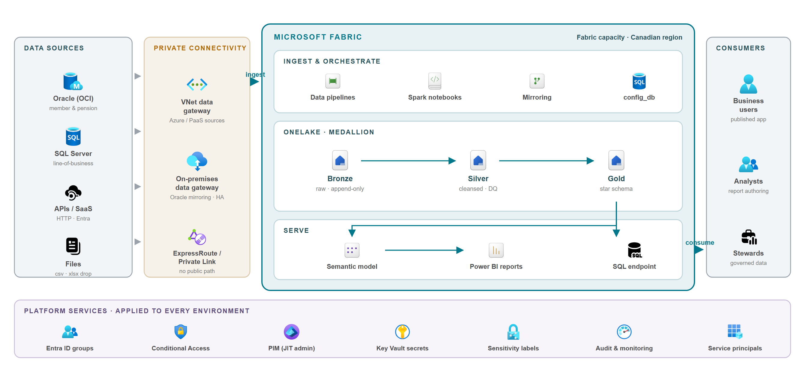
Figure 1 — Logical architecture. Sources reach Fabric through the VNet or on-premises data gateway; platform services apply to every environment.

What is distinctive about this design
- Configuration, not code, per source — sources, quality rules, models and security policies are declared as configuration held in git and promoted between environments. Onboarding a new source is a configuration change, which keeps the marginal effort per source small.
- One trusted copy — OneLake holds a single copy of the data; the SQL endpoint and semantic models read the same storage rather than taking further copies.
- Security declared alongside the data — row-level and column-level security and masking are part of the same configuration, applied per environment rather than hand-built.
- Auditable by construction — every source-to-Gold run is recorded, alongside Fabric's own lineage view.

Layer responsibilities
Layer | Holds | Access posture
Bronze | Raw landed data, append-only, retaining source history. | Platform and engineering only. Never exposed to report consumers.
Silver | Cleansed, de-duplicated and quality-checked data; failing rows quarantined. | Engineering and stewards; masking applied as data lands.
Gold | Modelled star schema — the governed data products. | The layer reporting reads, subject to row and column security.
Serve | Semantic models, Power BI reports and the SQL endpoint. | Business consumers, through a published app.

Workspace and environment model
Every environment is a hard boundary with its own workspaces, Entra groups, service principals, key vault and source connections. Production data never flows downward: lower environments run on masked or synthetic data. Promotion moves code and configuration only, executed by a deployment service principal.
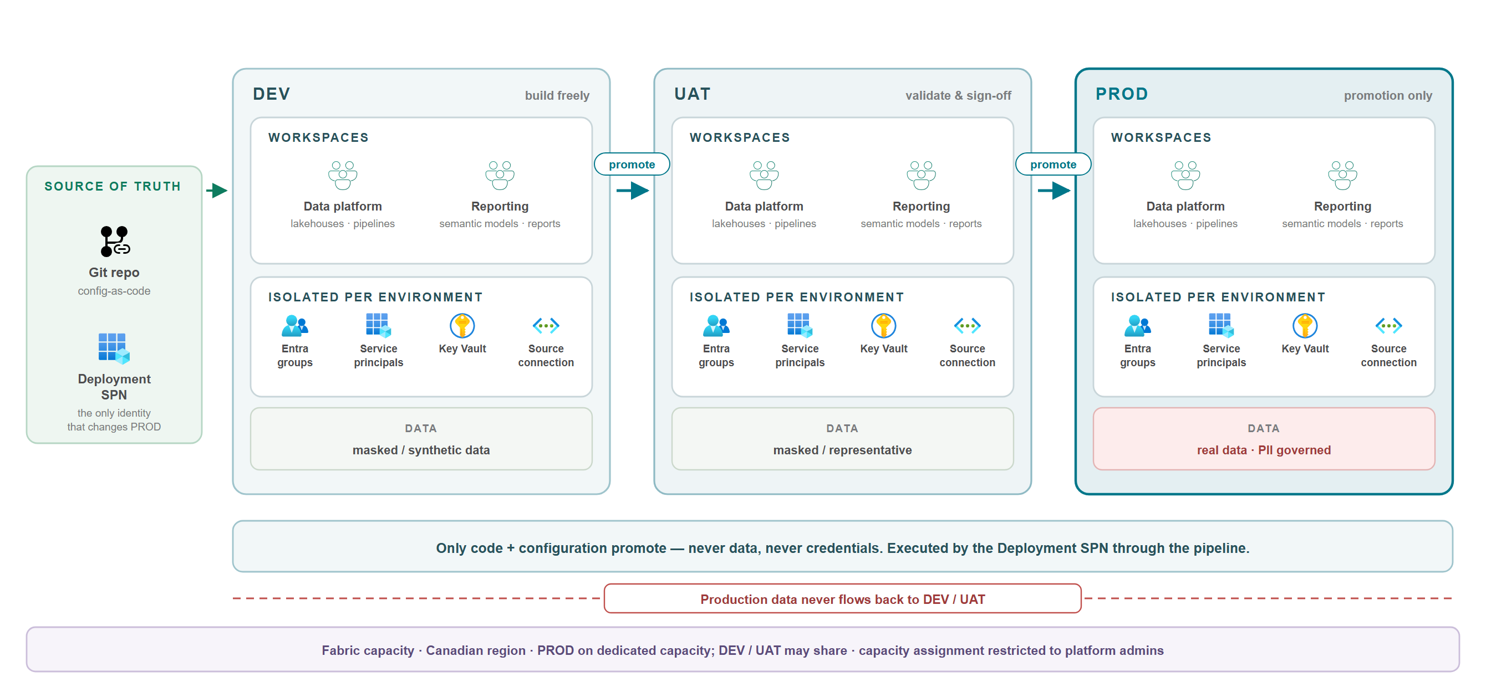
Figure 2 — Workspace, environment and deployment model.

Isolation matrix
Isolated per environment | DEV | UAT | PROD
Workspaces | separate | separate | separate
Capacity | shared acceptable | shared acceptable | dedicated (recommended)
Entra groups | own | own | own
Service principals | own | own | own
Key vault (secrets) | own | own | own — production credentials live only here
Source connection | DEV source | UAT source | PROD source
Data | masked / synthetic | masked / representative | real (PII governed)
Human change access | build freely | limited | none standing — promotion only

Access matrix — who gets what, where
This is the core of an access-control review: which persona gets which level in which environment. The shape — broad in DEV, tight in PROD, promotion-only for changes — is the part to scrutinise.
Persona / identity | DEV | UAT | PROD
Platform / Fabric admin | Admin (elevated on request) | Admin (elevated on request) | Admin — just-in-time with approval; break-glass held separately
Data engineer / developer | Contributor or Member | Viewer, or Contributor for fixes | No standing access — changes via pipeline only
Data steward | Member | Member | Viewer plus governance tooling (no data edits)
Report author / analyst | Contributor | Contributor (validate) | Author only in a dedicated authoring workspace; Viewer on curated data
Business consumer | — | Viewer (UAT sign-off) | Viewer through a published app only
Auditor / security | Viewer + audit logs | Viewer + audit logs | Viewer + audit logs
Deployment service principal | Member (deploy) | Member (deploy) | Member — the only identity that changes production
Runtime service principal | Contributor (run) | Contributor (run) | Contributor (run)
Gateway / connection account | read-only on DEV source | read-only on UAT source | read-only on PROD source

Promotion
Changes flow DEV → UAT → PROD through Fabric deployment pipelines and the control-plane deployment scripts, executed by the deployment service principal. Only code and configuration promote — never data, and never connection secrets, which are held per environment in that environment's key vault.

Security and access model
Access is granted to Microsoft Entra security groups, gated by Conditional Access and just-in-time elevation, and then narrows layer by layer inside Fabric — from tenant guardrails down to individual rows, columns and masked values. Automation runs as service principals with secrets in Key Vault, and every action is audited.
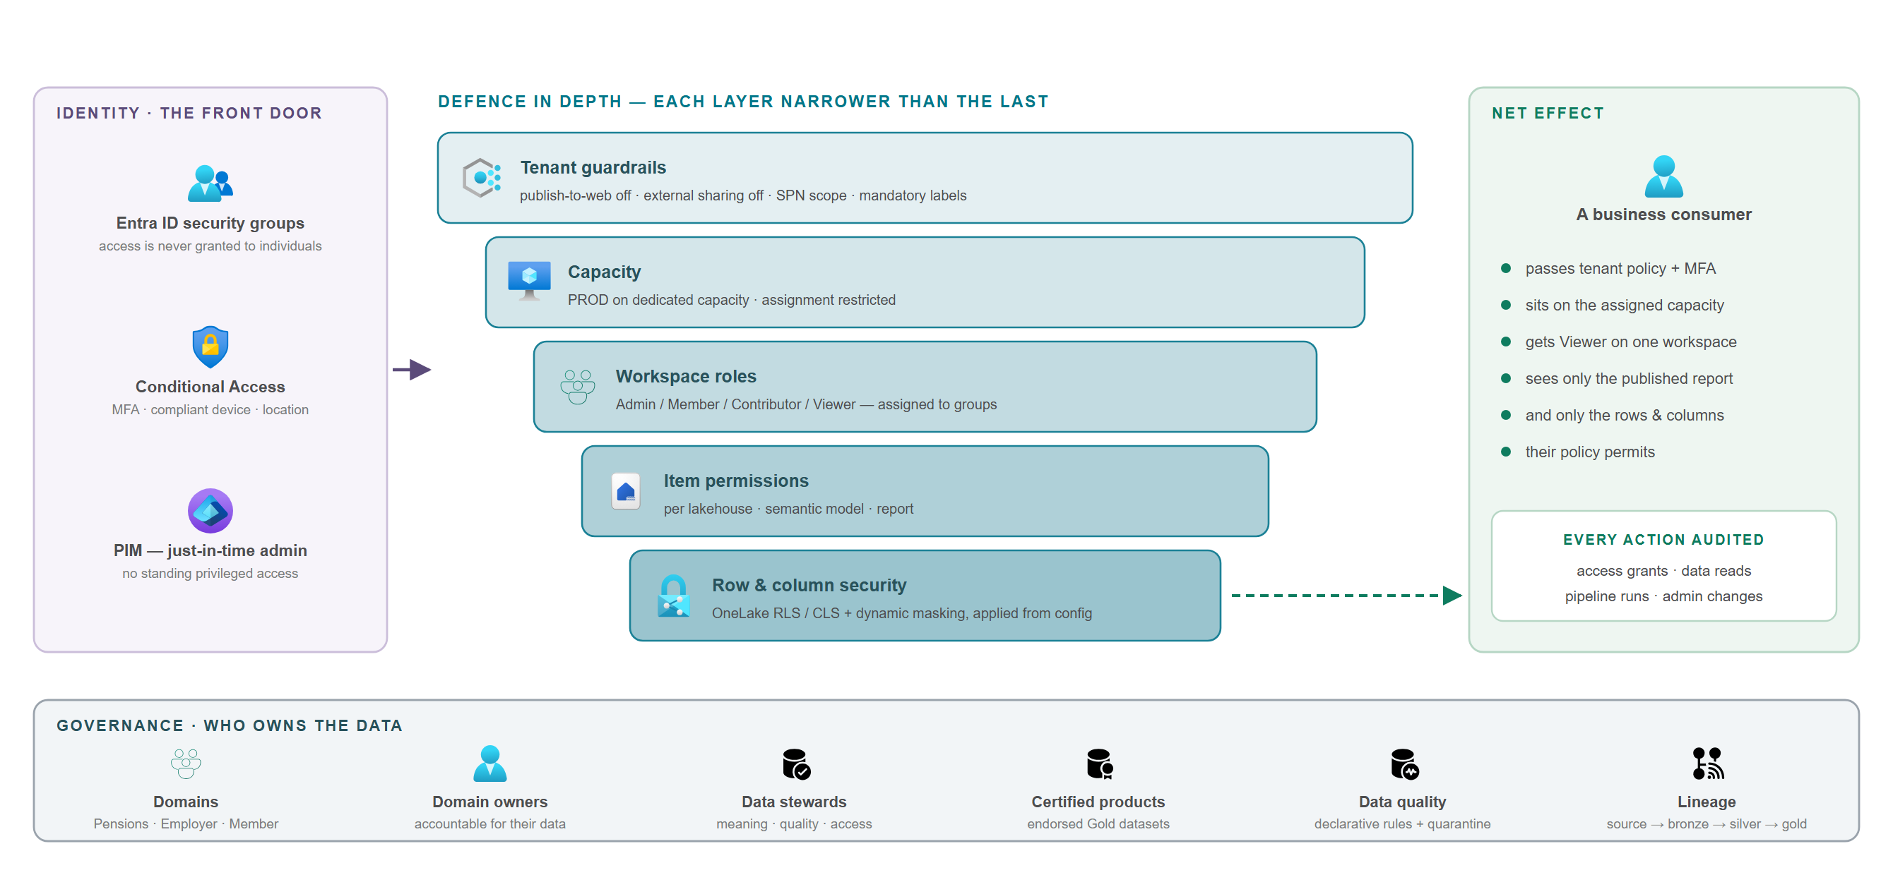
Figure 3 — Identity, defence in depth, and the governance operating model.

Guiding principles
- Group-based, never individual — all access is granted to Entra security groups; adding or removing a person is a membership change, and the permission model itself never changes.
- Least privilege and just-in-time — privileged and production access is granted on demand with approval, not held standing.
- People and machines do not mix — humans never authenticate as service principals, and automation never runs as a personal account.
- Production data stays in production — lower environments use masked, synthetic or subset data.
- Change production only by promotion — no manual edits in production.
- Private by default — no public-internet path to any source.
- Everything is auditable — access grants, data reads and pipeline actions are all logged.

Entra security groups
Group (naming convention) | Members | Purpose
BCPC-FAB-{ENV}-Engineers | Data engineers | Build access in that environment
BCPC-FAB-{ENV}-ReportAuthors | Analysts | Author semantic models and reports
BCPC-FAB-{ENV}-Consumers | Business users | View published reports through an app
BCPC-DATA-{DOMAIN}-Stewards | Data stewards | Governance for a data domain
BCPC-FAB-Platform-Admins | Platform team | Tenant and capacity administration — elevation required
BCPC-FAB-Auditors | Security and audit | Read and audit-log access
BCPC-FAB-SPN-{ENV} | Service principals | Automation identities; scopes API access

Defence in depth
Layer | Control
Tenant guardrails | Service-principal scope, publish-to-web off, external sharing off, mandatory sensitivity labels, Conditional Access.
Capacity | Production on dedicated capacity; workspace-to-capacity assignment controlled.
Workspace roles | Least-privilege Admin / Member / Contributor / Viewer, assigned to groups and reviewed on a cadence.
Item permissions | Per lakehouse, semantic model and report.
Data-level security | OneLake row-level and column-level security plus dynamic and static masking, applied from configuration per environment.

Machine identities
Identity (per environment) | Used for | Access
Deployment service principal | CI/CD — provision and promote code and configuration | Member on that environment's workspaces; the only identity that changes production
Runtime service principal | Scheduled pipeline and notebook execution | Contributor on that environment's workspaces
Gateway / connection account | Source connectivity through the gateway | Read-only on the source
Managed identity (preferred where supported) | Fabric-to-Azure resource access | Scoped to the specific resource; no credential to manage

Data protection
Control | Position
PII minimisation | Sensitive columns are masked or excluded as data lands in Silver, so sensitive values need never persist raw.
Row and column security | Applied from configuration, consistently per environment.
Masking | Dynamic masking at query time plus static masking during processing.
Sensitivity labels | Information Protection labels applied to items; labels travel with the data.
Data residency | Capacity and gateway virtual machines hosted in a Canadian region; no cross-geo processing.
Encryption | Encrypted at rest by default; customer-managed keys evaluated if policy requires.
Export controls | Publish-to-web disabled; export and download restricted on sensitive workspaces.

Enforcement note: OneLake row/column security and dynamic data masking restrict non-privileged (Viewer) users. Workspace administrators and owners see unmasked data — which is precisely why administrative access is group-based, elevated just in time, and audited.

Governance

Operating model
Role | Owns | Key responsibilities
Platform Owner | The Fabric platform and capacity | Capacity, tenant and admin settings, standards, release management.
Capacity Admin | Capacity sizing and guardrails | Monitoring, throttling and surge guardrails, scale and rebalance path.
Platform Admins | Tenant, gateways, releases | Tenant settings, gateway upkeep, deployment pipelines, incident response.
Domain Owners | Their business area's data | Accountable for the data in their domain (Pensions, Employer, Member).
Data Stewards | Meaning, quality and access | Definitions, quality rules and access decisions for their domain.
Data Product Owners | Governed Gold products | Each Gold output has an owner, a documented purpose and a consumer contract.

Tenant guardrails
Tenant setting | Recommended position
Service principals can use Fabric APIs | Enabled only for the BCPC-FAB-SPN-* group, not organisation-wide
Publish to web | Disabled
External / guest sharing | Disabled, or tightly restricted with approval
Export and download | Restricted for sensitive workspaces
Sensitivity labels | Enabled and enforced; mandatory labelling on new items
Audit logging | Enabled; logs shipped to BCPC's security monitoring
Workspace creation | Restricted to the platform team and a request process
Capacity assignment | Restricted — controls which workspaces run on which capacity
Conditional Access | Enforced on the Fabric and Power BI service

Optional tooling
The recommendation is to run on Fabric's built-in governance first — catalog, lineage, endorsement, data quality, audit, row/column security and sensitivity labels — and to add the tools below only where a specific requirement calls for them, since each carries licence and operational cost.
Tool | What it adds | Adopt when
Microsoft Purview | Enterprise catalog and data map, glossary at scale, DLP policies for Fabric, unified compliance reporting. | Governance must span beyond Fabric, or a formal DLP programme is required.
Microsoft Sentinel | SIEM — correlation, threat detection and response over Fabric and Entra audit logs. | A security operations centre is mandated and logs must feed central detection.
Defender for Cloud | Posture management for the surrounding Azure resources. | Broader Azure posture management is in scope.
Customer-managed keys | Bring-your-own encryption keys for OneLake and capacity. | Policy requires key custody beyond Microsoft-managed encryption.

Neither Purview nor Sentinel is required for the platform to be secure and governed at launch. Purview is the most likely near-term addition given classification and DLP expectations for a crown corporation.

Connectivity and gateway architecture
Two gateways are used, each for the role Microsoft supports it in. They are complementary, not competing.
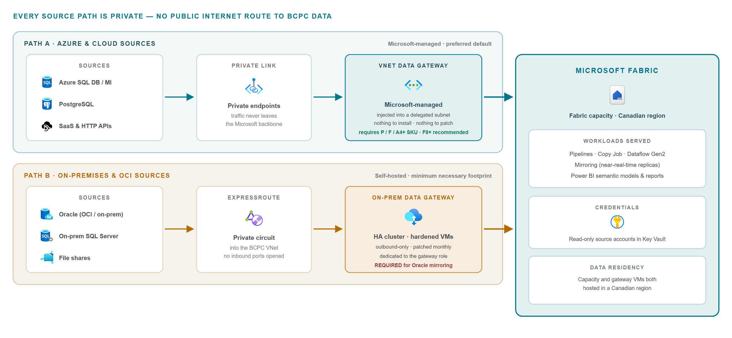
Figure 4 — Private connectivity. Path A is the Microsoft-managed default; Path B is the self-hosted path, kept to the minimum necessary footprint.
Dimension | VNet data gateway | On-premises data gateway
Hosting | Microsoft-managed — nothing to install or patch | BCPC-hosted Windows virtual machines, patched monthly
Where it lives | Injected into a delegated subnet of the BCPC virtual network | A machine BCPC owns, on-premises or an Azure VM
Reaches | Azure and cloud sources over private endpoint or the virtual network | On-premises and private sources; VNet resources when hosted on an Azure VM
Private connectivity | Private endpoints / Private Link — no public exposure | Outbound-only; private over ExpressRoute or VPN
Oracle mirroring | Not supported | Required — this is the only supported gateway
High availability | Managed by Microsoft | BCPC clusters the gateway machines
Capacity requirement | P / F / A4+ SKU; F8 or above recommended | Any
Operational cost | Lower — managed hardware | Virtual machine cost, patching, clustering and monitoring

Which gateway a mirrored source needs
A gateway is not an Oracle-only concern: any mirroring source behind a firewall needs one. What differs is which gateway each source accepts.
Mirroring source | On-premises gateway | VNet gateway | Note
Oracle (on-prem, Azure VM, OCI, Exadata) | Required | Not supported | Mandatory regardless of reachability
SQL Server | Yes | Yes | Either gateway when behind a firewall
Snowflake | Yes | Yes | Private Link to Fabric not yet supported
Azure SQL Database / Managed Instance | Yes | Yes | Either, when not public
Azure Database for PostgreSQL | — | Yes | VNet gateway for private servers
Google BigQuery (preview) | Yes | — | On-premises gateway
Cosmos DB, Fabric SQL DB, open mirroring | — | — | No gateway in the replication path

Position for BCPC
- Short term — reuse the existing VNet data gateway for Azure and private-endpoint sources and for pipeline ingestion; stand up a dedicated, highly available on-premises gateway only where it is required, principally Oracle mirroring.
- Long term — treat the VNet data gateway as the default managed path and minimise self-hosted gateway sprawl; as sources move to Azure or expose private endpoints, shift them across and shrink the on-premises footprint.
- Throughout — credentials in Key Vault, read-only source accounts, and governed control over who may create gateways and connections.
Note: Oracle mirroring requires broad database grants on the source. That is a further reason to isolate the on-premises gateway and its credentials from every other connection.

Component options
Where a Fabric implementation offers a choice, and what drives it.
Area | Decision
Capacity and residency | One Fabric capacity hosted in a Canadian region, sized to the workload in detailed design, with gateway virtual machines in the same region.
Data architecture | A medallion lakehouse on OneLake (Bronze → Silver → Gold). A warehouse is added only where a workload genuinely requires T-SQL write.
Configuration as code | Sources, quality rules, models and security policies are held as configuration in git and promoted between environments.
Environment isolation | Separate workspaces, Entra groups, service principals, key vaults and source connections for DEV, UAT and PROD.
Access model | Access granted to Entra security groups only, with Conditional Access on every session and just-in-time elevation for privileged and production roles.
Connectivity | The managed VNet data gateway is the default; a hardened, highly available on-premises gateway only where Microsoft requires it. Choosing the VNet gateway path means the capacity must be a P / F / A4+ SKU, F8 or above.
Governance tooling | Begin with Fabric's built-in governance; Purview and Sentinel are optional, added against a specific requirement.
Ingestion pattern | Framework ingestion into Bronze for batch sources; Fabric Mirroring where a source genuinely needs near-real-time replication.

What an implementation depends on
- A Fabric capacity is available in a Canadian region at a tier that supports the connectivity model.
- BCPC identity services can provision the required Entra security groups and Conditional Access policies.
- The tenant setting permitting service principals to use Fabric APIs can be enabled, scoped to a named group rather than organisation-wide.
- The Oracle source can meet Microsoft's prerequisites for mirroring, including archive logging and supplemental logging, and a supported gateway version.
- Non-production environments will be supplied with masked or synthetic data; no unmasked member data is loaded outside production.
- Hosting in a Canadian region satisfies BCPC's data-residency position.
- PIA, STRA and AI-assessment requirements are identified and actioned before the platform carries real member data.

Implementation considerations
Risk | Rating | Mitigation | Owner
Sensitive member data in a new platform | High | The design keeps lower environments on masked or synthetic data and admits real data only to production under row / column security and masking, with the access model confirmed with ITSO. | ITE / ITSO
Privileged access to production | High | No standing human change access to production; changes flow only through the deployment pipeline executed by a service principal, with administrator roles elevated just in time. | Platform Owner
Broad database grants required for Oracle mirroring | Medium | The on-premises gateway is dedicated, hardened and clustered, its credentials isolated in a per-environment key vault, and read-only accounts used everywhere else. | Platform Owner
Capacity contention and cost overrun | Medium | Production on dedicated capacity with surge protection and throttling guardrails; consumption monitored against the capacity allowance as a standing operational control. | Capacity Admin
Ungoverned workspace and report sprawl | Medium | Workspace creation restricted to a request-and-approve process; every workspace provisioned to standard from code; only reviewed Gold products certified. | Data Governance
Skills and adoption | Low | Adding a source is a configuration change rather than new code, keeping effort per source small; runbooks and working guides maintained alongside the platform. | Project team

Outside this architecture
- Migrating production reporting off the current platform.
- Decommissioning any existing system.
- Loading unmasked member data into a non-production environment.
- Any public-internet data path to a BCPC source.
- Adopting Purview or Sentinel, unless a specific requirement emerges in detailed design.

References
Microsoft documentation verified 2026-07-28.
Fabric security overview — https://learn.microsoft.com/en-us/fabric/security/security-overview
OneLake security (row and column level) — https://learn.microsoft.com/en-us/fabric/onelake/security/get-started-security
Fabric service principals — https://learn.microsoft.com/en-us/fabric/admin/service-principal
Fabric deployment pipelines — https://learn.microsoft.com/en-us/fabric/cicd/deployment-pipelines/intro-to-deployment-pipelines
Information protection in Fabric — https://learn.microsoft.com/en-us/fabric/governance/information-protection
Virtual network data gateway — https://learn.microsoft.com/en-us/data-integration/vnet/overview
On-premises data gateway — https://learn.microsoft.com/en-us/data-integration/gateway/service-gateway-onprem
Fabric Mirroring overview — https://learn.microsoft.com/en-us/fabric/mirroring/overview
Oracle mirroring prerequisites — https://learn.microsoft.com/en-us/fabric/mirroring/oracle
Fabric deployment patterns — https://learn.microsoft.com/en-us/azure/architecture/data-guide/technology-choices/fabric-deployment-patterns
Conditional Access — https://learn.microsoft.com/en-us/entra/identity/conditional-access/overview
Privileged Identity Management — https://learn.microsoft.com/en-us/entra/id-governance/privileged-identity-management/pim-configure
Diagram provenance: the figures are built from the official Microsoft Azure architecture icons and the Microsoft Fabric product icons. Oracle is a third-party product with no Microsoft icon and is drawn as a labelled element using a neutral database mark.

